

Victoria University Business School

BBB7000
Applied Business Project
Technical Report – Safe2Support
Instructor name: Dr. Scott Bingley

Student Name | Student ID
Maneth B | s8065240
Luai Bawazir | s4659370
Vrishank Mani | s4680492
Tehara Perera | s8075741
Table of Contents
1 Introduction 1
2 Purpose 1
2.1 Key Objectives: 1
3 Proposed Solution 3
3.1 Home Dashboard 4
3.1.1 Purpose 4
3.1.2 UI Design Description 4
3.1.3 Code 5
3.1.4 Evaluation Metrics/Quality Assurance Steps 6
3.2 Donations 7
3.2.1 Purpose 7
3.2.2 UI Design Description 7
3.2.3 Code 9
3.2.4 Evaluation Metrics/Quality Assurance Steps 10
3.3 Donations – Donate Now Screen: 10
3.3.1 Purpose 10
3.3.2 UI Design Description 11
3.3.3 Code 12
3.3.4 Evaluation Metrics/Quality Assurance Steps 13
3.4 'Find Items Screen 14
3.4.1 Purpose 14
3.4.2 UI Design Description 14
3.4.3 Code 17
3.4.4 Evaluation Metrics/Quality Assurance Steps 18
3.5 'Umbrella Results Screen' 19
3.5.1 Purpose 19
3.5.2 UI Design Description 19
3.5.3 Evaluation Metrics/Quality Assurance Steps 20
3.6 'Blue Umbrella Detail Screen' 20
3.6.1 Purpose 20
3.6.2 UI Design Description 21
3.6.3 Evaluation Metrics/Quality Assurance Steps 21
3.7 'Jackets Results Screen' 22
3.7.1 Purpose 22
3.7.2 UI Design Description 22
3.7.3 Evaluation Metrics/Quality Assurance Steps 23
3.8 'Hats/Caps Results Screen' 24
3.8.1 Purpose 24
3.8.2 UI Design Description 24
3.8.3 Evaluation Metrics/Quality Assurance Steps 25
3.9 'Boots Results Screen' 25
3.9.1 Purpose 26
3.9.2 UI Design Description 26
3.9.3 Evaluation Metrics/Quality Assurance Steps 26
4 Amenities 27
4.1 Purpose 27
4.2 UI Design Description 27
4.3 Code and Integration Components 28
4.4 Evaluation Metrics/Quality Assurance Steps 31
5 News 32
5.1 Purpose 32
5.2 UI Design Description 33
5.3 Code 33
5.4 Evaluation Metrics/Quality Assurance Steps 35
6 PTV 36
6.1 Purpose 36
6.2 UI Design Description 36
6.3 Code 37
6.4 Evaluation Metrics/Quality Assurance Steps 38
7 Health 39
7.1 Purpose 39
7.2 UI Design Description 39
7.3 Code 40
7.4 UI Design Implementation 40
7.5 Evaluation Metrics/Quality Assurance Steps 41
8 Finances 42
8.1 Purpose 42
8.2 UI Design Description 42
8.3 Code 43
8.4 Evaluation Metrics/Quality Assurance Steps 45
9 SafeDocs 46
9.1 Purpose 47
9.2 UI Design Description 47
9.3 Code 48
9.4 Evaluation Metrics/Quality Assurance Steps 48
10 Job Board 49
10.1 Purpose 49
10.2 UI Design Description 49
10.3 Code 50
10.4 Navigation Bar Implementation 51
10.5 Evaluation Metrics/Quality Assurance Steps 52
11 Challenges & Recommendations 52
11.1 Integration of Map APIs Across Devices 52
11.2 Delays and Inaccuracies in PTV API Updates 53
11.3 Security and Data Privacy Concerns 53
11.4 Scalability and Maintenance of Kiosk Systems 53
11.5 Engagement and Awareness Among the Homeless Population 54
12 Conclusion 54

Introduction
Homelessness represents one of the most persistent and complex challenges within urban settings globally, and especially in the 21st century, it remains without definitive resolution. In Victoria, Australia, this issue is particularly pronounced, with the Australian Institute of Health and Welfare reporting nearly 100,000 individuals experiencing homelessness, equating to approximately one in every 67 residents (AIHW, 2024). The genesis of homelessness can be attributed to a blend of structural and individual risk factors that complicate the lives of those affected.
The proposed technical solution aims to leverage existing urban infrastructure, specifically payphones, transforming them into access points for essential services that address the immediate and long-term needs of homeless individuals. This project intends to use these underutilized resources to provide easy access to critical online services that could significantly improve the quality of life for the homeless.

Purpose
The primary purpose of this project is to harness existing urban infrastructure to significantly improve the living conditions of homeless individuals across Australia. By transforming payphones into multi-functional service kiosks, this initiative seeks to provide on-demand access to essential services and information that are crucial for meeting the basic needs of the homeless population.

Key Objectives:
- Empowerment Through Information: Beyond immediate physical needs, the kiosks will provide access to critical information on healthcare, financial services, and employment opportunities, empowering users to take proactive steps towards improving their circumstances.
- Integration with Public Services: By integrating these kiosks with public service databases and support systems, the project ensures that users have real-time access to updated resources and assistance, thereby maximizing the relevance and impact of the services provided.
- Promotion of Safety and Security: Each kiosk will serve as a safe point of interaction for vulnerable individuals, providing them with emergency contact mechanisms and quick access to health and safety resources.
- Community Support and Engagement: The project aims to foster a sense of community and support among homeless individuals by providing a reliable access point for communal and supportive services like job boards, legal document storage, and community event information.
This initiative is rooted in the belief that access to information and basic services is a fundamental right that should be accessible to everyone, regardless of their living situation. By repurposing payphones, which are widely recognized but underutilized assets, this project creatively addresses the practical needs of homeless individuals, offering them dignity, safety, and opportunities for improvement in their daily lives. The ultimate goal is to make a tangible, positive impact on the lives of thousands of homeless individuals across Victoria, setting a precedent for similar innovations in other region

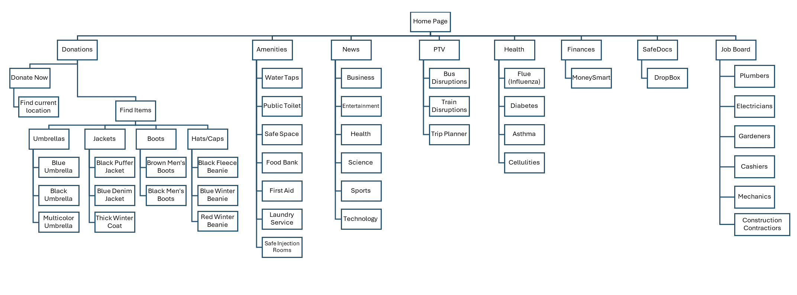
Proposed Solution

Home Dashboard

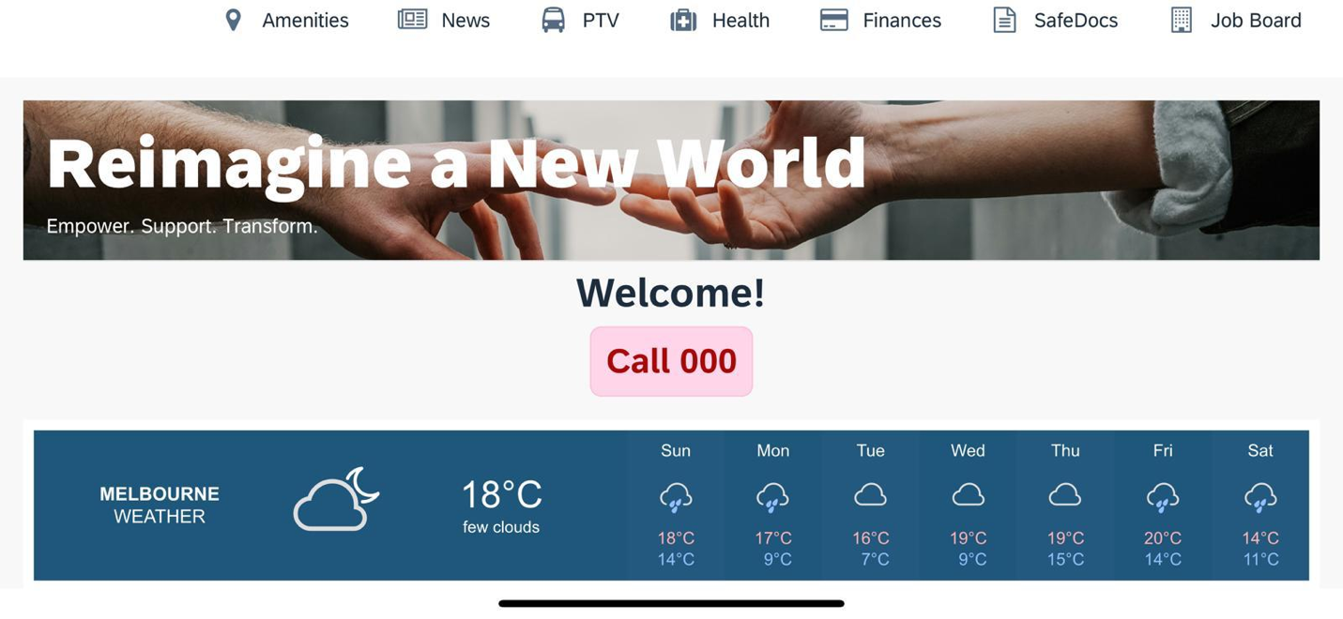

Purpose
The Home Dashboard will act as the ‘Welcome Page’ for the user. This will be the first screen that the user will view when they approach the payphone. The user can access all other services through this page and would be notified of basic information like date, time and temperature forecasts through this opening screen. The purpose of this dashboard is to make navigation through the system easier and user friendly so that when a homeless person uses it, he/she can access the service they want quickly and efficiently.

UI Design Description
This page has been designed so that all important and useful buttons are placed at the top of the screen, well within the sight of the user. At the top we will have our logo on the left, and buttons to navigate to other services like Amenities, Donations, PTV etc next to it. Below that, we will have our welcome text along with an emergency call button, which when clicked will automatically dial ‘000’ for the user. Beyond that we will include the date and time along with a weather widget, which when tapped will open the detailed weather info page. And finally at the bottom of the page, the user will find banners mentioning the mission, vision and purpose of this interface.

Code
- Weather API Integration
The weather widget displays real-time weather information for Melbourne, including the current temperature, weather description, and a 5-day forecast. The integration of the Weather API allows for dynamically updated data that reflects the current conditions. This was done using Openweather API and get record collection call as a REST API in SAP Build. The weather API response is based on location latitude and longitude. In the GPS location function in SAP build the latitude and longitude is obtained and this feeds onto the API which retrieves the forecast for the specific location where the payphone is situated.
- Static UI Elements
The rest of the Home Dashboard comprises static content that includes a banner image, welcome text, and an emergency call button. These elements are built using basic SAP Build Apps components like Text and Button.
Banner Image: A static image is displayed at the top of the dashboard. This banner image is uploaded and managed via the Media Manager in SAP Build Apps.
The image serves as a welcoming visual that sets the tone for the application, conveying a message of support and transformation.
Welcome Message: The welcome text ("Welcome!") is a static Text Component placed centrally on the screen. This message is formatted to stand out and make the user feel acknowledged upon entering the app.
Call 000 Button: The Emergency Call Button ("Call 000") is created using a Button Component. The button’s action is configured to trigger the phone’s dialer and pre-fill it with "000," allowing users to make an emergency call instantly.
The button’s visibility and placement make it easily accessible to ensure safety and quick emergency access.
- Top Navigation Bar
The Navigation Bar located at the top of the screen allows users to navigate between different services offered in the app. This feature is consistent across all screens to ensure ease of access and improve user flow.
Navigation Components: Each service is represented by an icon and text in the navigation bar. Icons for Amenities, News, PTV, Health, Finances, SafeDocs, and Job Board are configured with links to their respective screens.The navigation bar is positioned at the top for visibility and accessibility, ensuring users can seamlessly move between different sections.
OnClick Events: The OnClick actions for each navigation item are set to redirect users to the corresponding service page within the app. For example, clicking on the "Health" icon takes the user to the Health Services screen.
- Layout and Styling
The overall layout of the Home Dashboard uses a simple and clean design, ensuring all key information and navigation options are easily accessible without clutter.

Evaluation Metrics/Quality Assurance Steps
To ensure the home dashboard meets the project's goals, the following evaluation metrics and QA steps will be applied:
- Response Time: Measuring the time taken to open new pages once the navigation buttons have been clicked.
- Usability Testing: Conducting user tests ensure the interface is easy to navigate and understand.

Donations

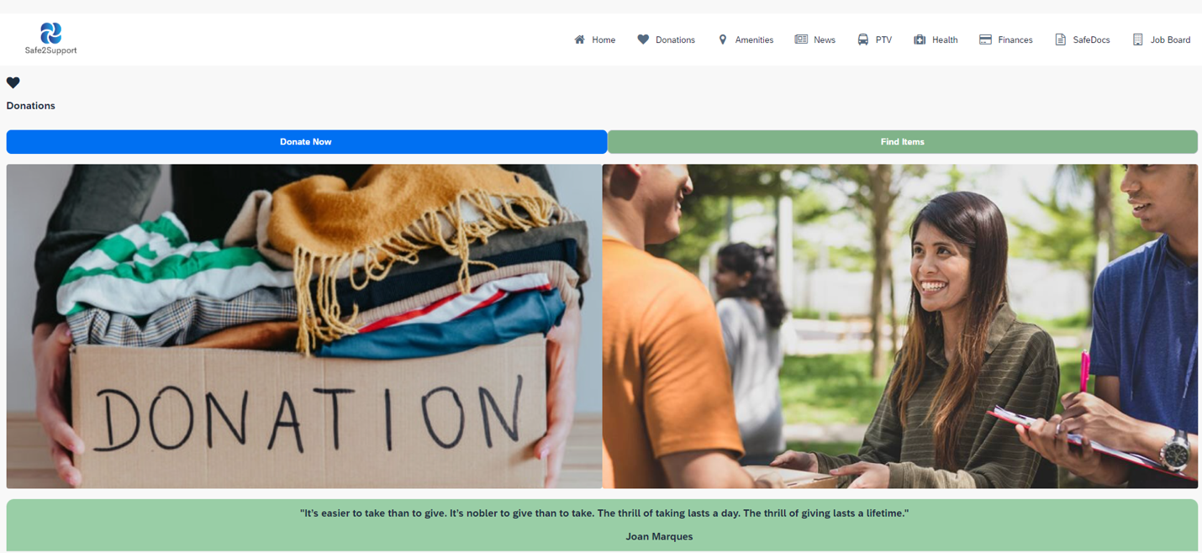

Purpose
The Donations Page is designed to connect homeless individuals with resources that can help them meet their basic needs. This screen offers two main features: 'Donate Now,' which allows users to donate reusable items, and 'Find Clothes,' which helps users locate clothing in good condition. The purpose of this page is to facilitate the redistribution of essential items within the community, ensuring that those in need can easily access them.

UI Design Description
'Donate Now' Button: This prominently displayed button will direct users to a service that allows them to donate items such as clothing, shoes, blankets, and other reusable goods. The button will be large, clearly labeled, and located at the top of the screen for easy access.
Under the button logic canvas, we selected the ‘Open Page’ navigation component and linked it with the ‘Component Tap’ event. Then, under the ‘Properties’ header for the ‘Open Page’ component, we set the page to open to the ‘Donations’ page.
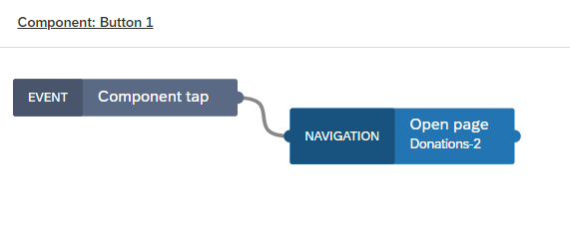
'Find Clothes' Feature: Next to the 'Donate Now' button, the 'Find Clothes' feature will be presented. This will include a search function or a list of locations where users can find clothing. Each location entry will provide details such as address, opening hours, and the types of clothing available.
Under the button logic canvas, we selected the ‘Open Page’ navigation component and linked it with the ‘Component Tap’ event. Then, under the ‘Properties’ header for the ‘Open Page’ component, we set the page to open to the ‘Find Items’ page.
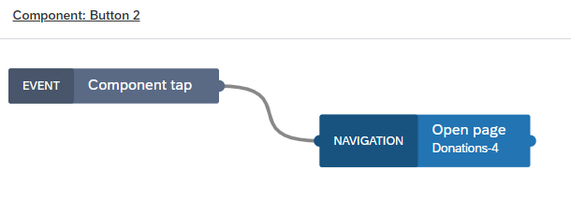

Icons and Visual Cues: To enhance usability, both buttons will be accompanied by pictures—such as a hand with a 'Donate’ cardboard image and an image of a donations point for 'Find Clothes.' These visual cues will help users quickly identify the service they need.
Navigation Bar: A navigation bar at the top of the screen will allow users to easily move between different sections of the app, ensuring they can quickly return to different pages as needed.

Code
The Donations Page will be developed with the following technical aspects:
• Integration with Location-Based Services: Both the 'Donate Now' and 'Find Clothes' buttons will be connected to location-based services to display a list of the nearest donation points or clothing distribution centres based on the user's current location. The system will automatically sort the results by proximity.
• Backend Data Management: A backend system will store and update information about donation points and clothing centers. This data will include addresses, operating hours, and types of items accepted or distributed. Regular updates will ensure that users always receive accurate information.
• User Interface Interactivity: Clicking on either button will dynamically load the list of nearby locations, with details presented in a user-friendly format. Users can tap on a location to get more details or directions.

The Donations Page will be developed with the following technical aspects:
- Integration with Location-Based Services: Both the 'Donate Now' and 'Find Clothes' buttons will be connected to location-based services to display a list of the nearest donation points or clothing distribution centres based on the user's current location. The system will automatically sort the results by proximity.
- Backend Data Management: A backend system will store and update information about donation points and clothing centers. This data will include addresses, operating hours, and types of items accepted or distributed. Regular updates will ensure that users always receive accurate information.
- User Interface Interactivity: Clicking on either button will dynamically load the list of nearby locations, with details presented in a user-friendly format. Users can tap on a location to get more details or directions.

Evaluation Metrics/Quality Assurance Steps
To ensure the effectiveness and reliability of the Donations Page, the following evaluation metrics and QA steps will be used:
- Form Functionality: Testing the 'Donate Now' form to ensure that all fields are working correctly, inputs are properly validated, and submissions are successfully processed.
- Search Accuracy: Verifying that the 'Find Clothes' feature accurately returns relevant results based on user location and search criteria.
- Load Times: Measuring the time it takes for the Donations Page to load and for search results to be displayed, aiming for a quick and smooth user experience.
The Donations Page is a vital component of the proposed application, offering a practical solution for both donating and finding essential clothing items. By integrating a user-friendly interface, reliable backend systems, and thorough quality assurance measures, this page will significantly contribute to the app's goal of supporting the homeless community. The Donations Page not only facilitates the redistribution of resources but also empowers users to access the items they need, fostering a sense of community and mutual support.

Donations – Donate Now Screen:

Purpose
The 'Donate Now' screen is designed to help users locate and navigate to the nearest drop-off points for reusable items, making it easier to contribute to those in need. It provides a user-friendly interface for finding donation locations and viewing them on a map.
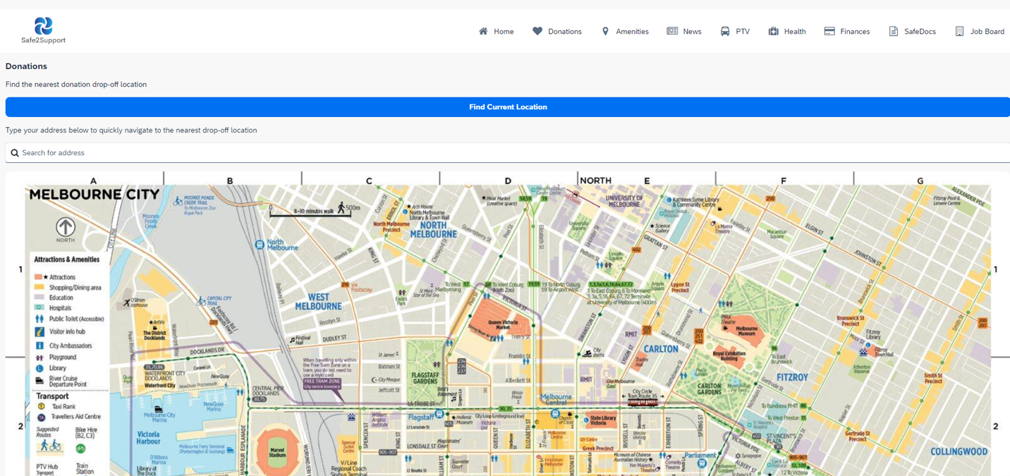

UI Design Description
- Top Navigation Bar: A navigation bar at the top allows users to easily switch between different screens of the application, including 'Find Clothes,' 'Events,' 'PTV,' and more.

- Find the Nearest Drop-Off Location Text: Prominently displayed text guides users on finding the closest donation locations. This text ensures users understand the purpose of the screen.

- ‘Find Current Location’ Button: This button utilizes the device’s GPS to determine the user's current location and updates the map to show the nearest drop-off locations. It enhances the functionality of the screen by providing real-time location data.
Under the button logic canvas, we have linked the Device ‘GPS location’ component and linked it with the ‘Component Tap’ Event component. Then, we have further linked the top node of the ‘GPS Location’ component (positive node: which gets activated when the GPS location is found) with the ‘Open Page’ navigation component to open the ‘Drop off loc’ page which contains the nearest drop off locations.
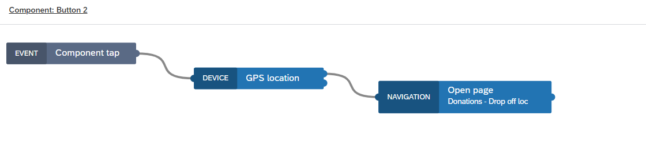
- Search Bar: This search bar allows the user to search for an address. The system will find the nearest donation points to the inputted address and return the address.
Under the button logic canvas, we have linked the ‘Property ‘Value’ changed’ component and linked it with the ‘Open Page’ navigation component to open the ‘Drop off loc’ page which contains the nearest drop off locations.

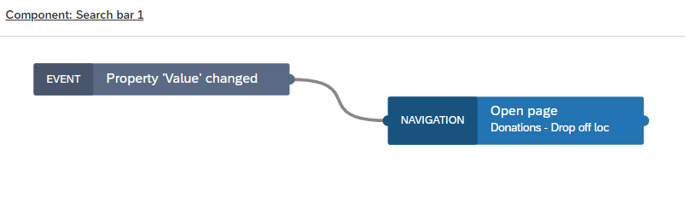

Code
The "Donate Now" screen is designed to allow users to locate the nearest drop-off points for donations of reusable items. The screen includes a GPS-based feature to find nearby locations based on the user's current position or a manual search by address. This screen uses location-based APIs and interactive input elements, such as search bars, to enhance user experience and functionality.
- Location-Based API Integration: The key functionality of the "Find Current Location" button is powered by the device’s GPS through a location-based API. When a user clicks on the button, the API gathers the user’s current GPS coordinates and searches for nearby drop-off points from the database.
Button Trigger Action: When the "Find Current Location" button is pressed, it triggers a function to call the GPS location service through SAP Build Apps' Device GPS Location functionality, obtaining the latitude and longitude of the user's current location.
API Fetch Request: Once the location is retrieved, the coordinates are sent as a parameter to a REST API that contains the database of donation centers. The response is a list of locations sorted by proximity.
- Display of Results
After either the "Find Current Location" button or address search is used, the nearest drop-off locations are shown on the screen. These results are sorted by proximity and include important details such as the donation center name, address, and operating hours.
Card Layout: Each location is displayed as a card that includes:
- Name of the donation center
- Address and contact information
- Operating hours (if applicable)
- Distance from the user’s location (calculated based on GPS or address coordinates)

Evaluation Metrics/Quality Assurance Steps
- Accuracy of Location Data: Verify that the map correctly shows donation points and updates in real time based on the CBD location.
- Map Load Time: Ensure the map and location data load quickly without significant delays.
- Usability Testing: Test the functionality of the 'Find Current Location' button and ensure it provides accurate and timely information.
- Cross-Platform Testing: Ensure the map and location features work across various devices and screen sizes.
The 'Donate Now' screen provides a crucial function for connecting users with nearby donation points. Its integration with real-time location services and a map ensures that users can efficiently find and navigate to drop-off locations, enhancing the overall usability and effectiveness of the donation process.

'Find Items Screen

Purpose
The 'Find Clothes' screen assists users in locating nearby places where they can obtain clothing, facilitating access to essential items for those in need.
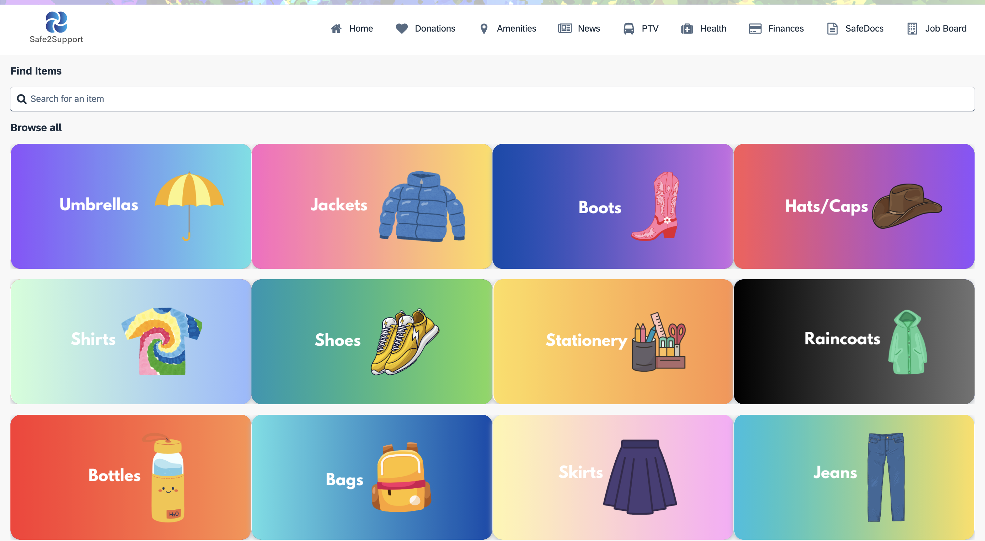

UI Design Description
- Top Navigation Bar: This bar allows users to navigate to other parts of the application seamlessly, including ‘Home Page,' 'Events,' and more.
- Search Bar: A search bar labelled "Search for an Item" enables users to input specific clothing items they are looking for. This functionality allows for a more targeted search within available resources.
This search bar is slightly different from other search bars. This search bar gives search suggestions to the user based on the letter already typed. This is done by creating a search list and adding an app variable that holds the search items. Then, by using the formula (in the image below) in the ‘Repeat with’ section of the properties tab, we can achieve the required result.

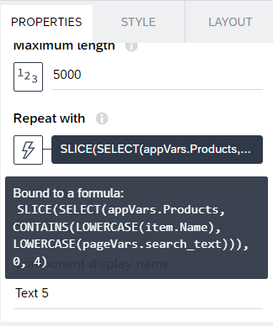

Once that is done, we can link the search items with the ‘Open page’ component to open the intended page.
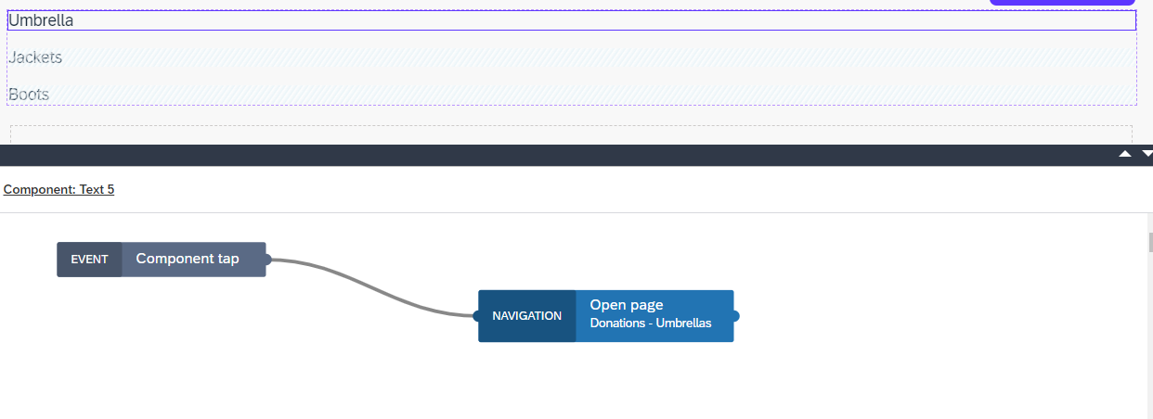

- Items Recommendation Display: Below a 'Browse All' text, users will see recommendations and listings of available items. This feature helps users quickly find clothing that meets their needs. Includes buttons of Umbrellas, Jackets, Boots, and Hats/Caps.
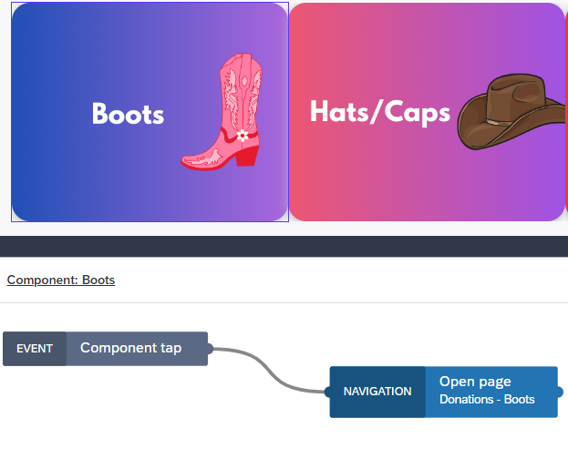
In this section, there are multiple search recommendation buttons that use the same navigation logic as before to open different pages based on the item clicked.

Code
- Top Navigation Bar
The Top Navigation Bar is a recurring component across the application, providing users with seamless navigation to other services like Home Page, Events, and Donations. This bar is built using the default navigation options provided by SAP Build Apps, where each icon is linked to its respective page using navigation logic.
- Search Bar
The Search Bar at the top allows users to input the name of an item they are looking for. The search functionality is enhanced by implementing a dynamic search suggestion feature.
Dynamic Search Suggestions:
A search suggestion list is created, and an app variable (appVars.Products) is used to hold the names of all available items.
The search bar uses the Repeat with property in the component to display suggested search results based on the user's input. A formula is applied to filter and show only those items that match the user's search term as they type.
- Item Search Results and Navigation
Once the user starts typing in the search bar, the dynamic list of matching items appears, which users can tap to navigate to the relevant item page.
Open Page Logic: Each search result is linked to an event called Component Tap. When a user taps on any of the displayed results, the Open Page logic is triggered, directing the user to the relevant product page
- Items Recommendation Display
Below the search bar, there is a Browse All section that showcases recommended items in a grid layout. Each item is represented by a button (e.g., Umbrellas, Jackets, Boots, Hats/Caps, etc.).
Button Logic: Each button is linked to a specific product category and functions similarly to the search results. Upon clicking any of these recommendation buttons, the user is navigated to the corresponding item results page.
Navigation: The Component Tap event is used to navigate the user to the appropriate category page when they click on a button. For instance, if the user clicks on Umbrellas, they are redirected to the Umbrella Results Page.
- Backend Integration
The Find Items screen does not require complex backend integration since the items listed are based on static content defined within the app’s variables. However, it can be extended to integrate with a real-time inventory management system, which would dynamically update the list of items and their availability.

Evaluation Metrics/Quality Assurance Steps
- Search Accuracy: Test the search bar to ensure it returns relevant results based on user input and provides accurate information about clothing resources.
- Load Time: Evaluate the speed at which search results and recommendations are displayed.
- Usability Testing: Assess how intuitive and user-friendly the search and browsing features are, ensuring users can easily find and access clothing resources.

The 'Find Items' screen enhances the app’s functionality by allowing users to search for and browse clothing resources. Its intuitive design and integration with a searchable database ensure users can easily locate and obtain the clothing they need, contributing to the overall goal of supporting homeless individuals in accessing essential resources.

'Umbrella Results Screen'

Purpose
The 'Umbrella Results Screen' provides users with a list of available umbrellas at nearby donation centers, streamlining the process of finding specific items. This screen is part of the broader "Find Items" service designed to assist users in quickly locating essential items.
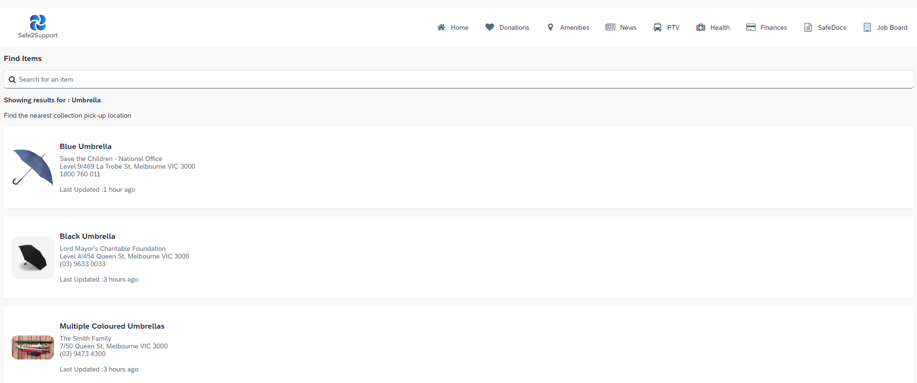

UI Design Description
- Top Navigation Bar: This bar allows users to navigate to other parts of the application seamlessly, including ‘Home Page,' 'Events,' and more.
- Results Header: Displays the search query 'Umbrella' at the top, reaffirming to users that they are viewing umbrella-specific results.
- Collection Point Information: Each listing includes a visual representation of the item, the name of the donation center, its address, contact number, and the time since the last update. This detailed information aids users in determining the most convenient pick-up location.
- Interactive Elements: Each item can be clicked to reveal further details or to initiate a navigation route to the chosen collection point.

Evaluation Metrics/Quality Assurance Steps
- Result Relevance: Evaluate how well the displayed items match the users' search criteria.
- Information Accuracy: Regular checks to ensure that contact details and item availability are up-to-date.
- User Interaction: Monitor user interactions to refine UI elements for better accessibility and ease of use.
The 'Umbrella Results Screen' enhances the functionality of the app by providing a targeted and user-friendly interface for users to access specific items like umbrellas. By offering concise and relevant information, it ensures that users can make informed decisions quickly, supporting the app's goal of helping individuals access essential resources efficiently.

'Blue Umbrella Detail Screen'

Purpose
The 'Blue Umbrella Detail Screen' provides comprehensive information about the blue umbrella available at a specific donation center. This screen is designed to give users all the necessary details to facilitate their decision-making process in acquiring the item.
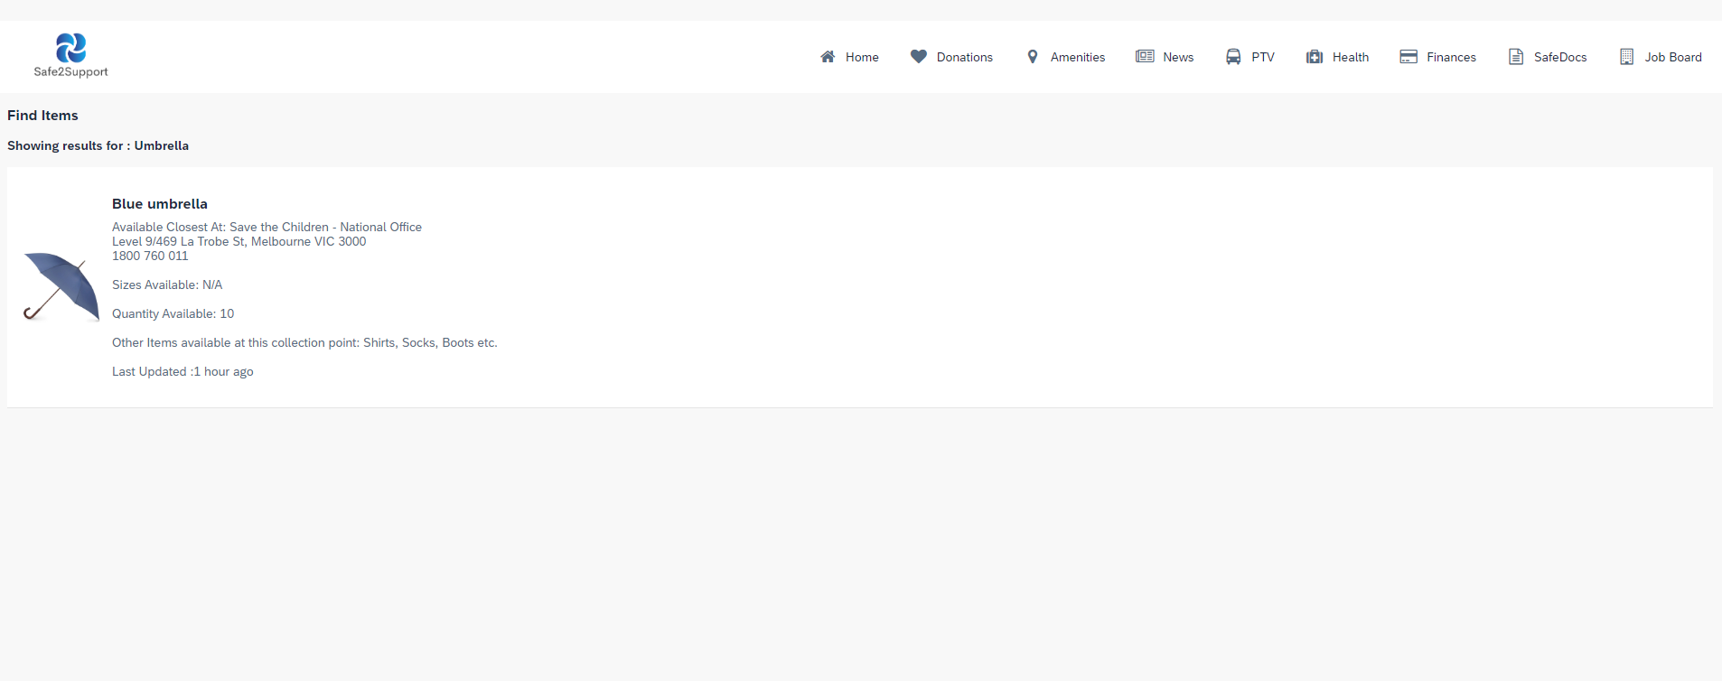

UI Design Description
- Top Navigation Bar: This bar allows users to navigate to other parts of the application seamlessly, including ‘Home Page,' 'Events,' and more.
- Item Description: Displays a prominent image of the blue umbrella, along with essential details such as the location, contact number, and available quantity at the Save the Children - National Office. It ensures users have clear and immediate access to the most critical information.
- Availability and Sizing: Lists the number of umbrellas available. If applicable, size information would also be provided here.
- Additional Items: Highlights other items available at the same collection point, like shirts, socks, and boots, encouraging further engagement with the app and maximizing the utility of each visit to the donation center.
- Update Information: The last updated timestamp assures users of the data’s currency, enhancing trust in the provided information.

Evaluation Metrics/Quality Assurance Steps
- Detail Accuracy: Regular verification to ensure that all the information displayed is accurate and up-to-date.
- User Engagement: Track user interaction with this screen to assess if the information provided meets their needs and prompts further action.
- Feedback Mechanism: Implement and monitor a feedback option to gather user insights on the utility of the information provided and identify areas for improvement.
The 'Blue Umbrella Detail Screen' plays a crucial role in the 'Find Items' service by delivering detailed and actionable information about specific items. This screen aims to ensure users have a frictionless experience in accessing necessary items, supporting the broader goal of aiding those in need with essential resources.

'Jackets Results Screen'
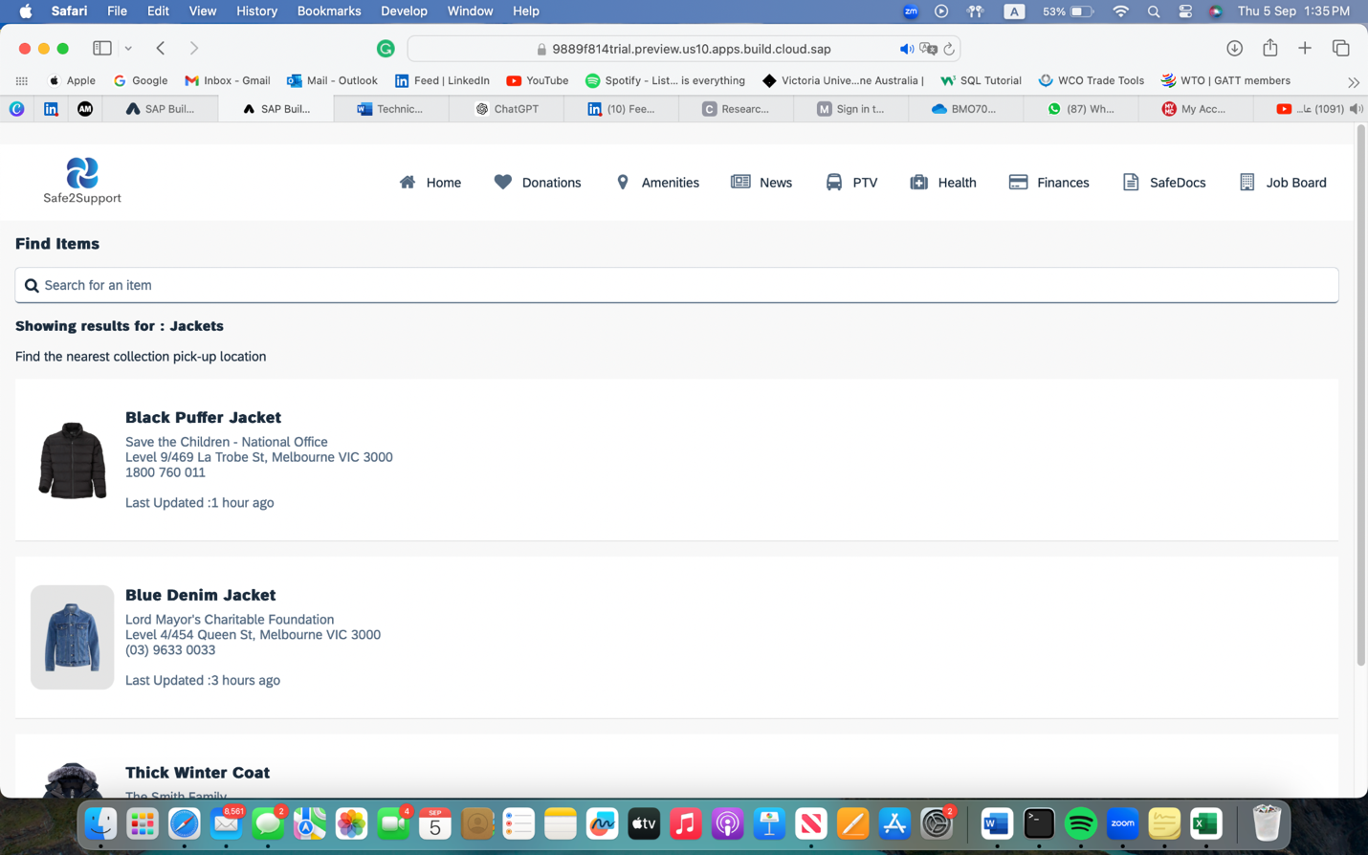

Purpose
The 'Jackets Results Screen' is specifically tailored to assist users in finding various types of jackets available at nearby donation centers. This functionality is part of the "Find Items" service, which aims to provide easy access to essential clothing items for those in need.

UI Design Description
- Top Navigation Bar: This bar allows users to navigate to other parts of the application seamlessly, including ‘Home Page,' 'Events,' and more.
- Results Header: This section confirms the users' search for jackets, ensuring they are aware they are viewing results related to jackets only.
- Listing Details: Each jacket listing provides an image of the jacket, along with the name of the donation center, its address, and contact number, coupled with the time since the information was last updated. This helps users decide where to pick up their desired jacket based on convenience and recency.
- Interactive Options: Users can interact with each listing either by clicking for more details or directly initiating a route on a map to the selected donation center.

Evaluation Metrics/Quality Assurance Steps
- Relevance of Results: Test to ensure that the search functionality accurately pulls up jackets according to user queries.
- Timeliness of Information: Maintain up-to-date contact and availability information to help users make informed decisions.
- Ease of Navigation: Conduct user testing to verify that the navigation between different screens and options is intuitive and seamless.
The 'Jackets Results Screen' enhances the overall usability of the app by providing a specialized interface where users can effectively locate jackets. Detailed listings and easy navigation ensure a user-friendly experience, facilitating quick access to essential resources, which is vital for supporting individuals in need.

'Hats/Caps Results Screen'
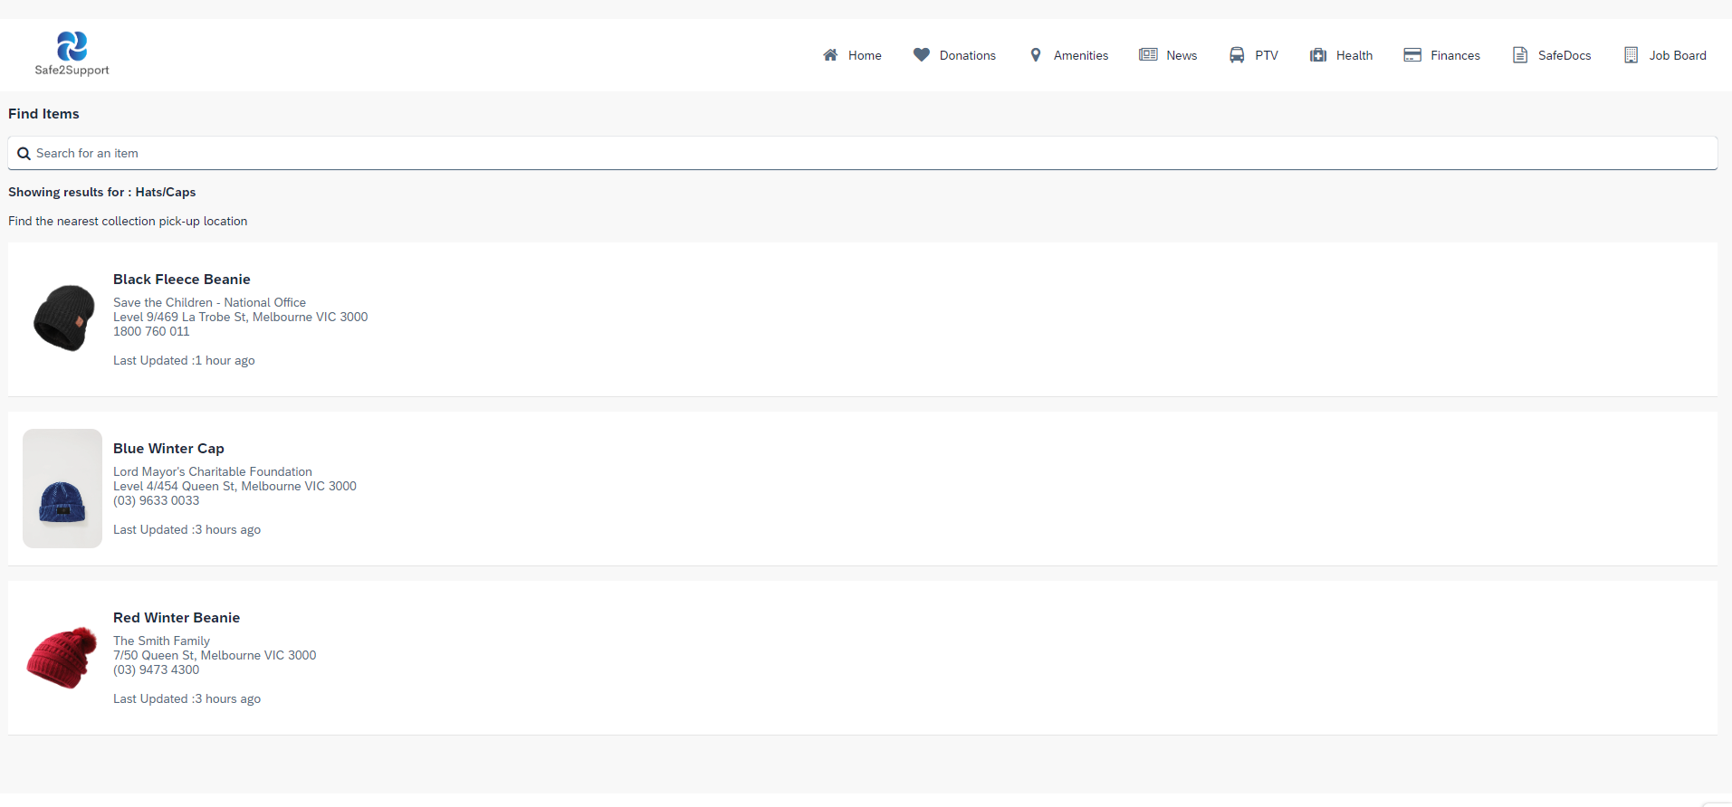

Purpose
The 'Hats/Caps Results Screen' showcases a selection of hats and caps available at nearby donation centers, facilitating users in finding suitable headwear quickly and efficiently. This screen is integral to the "Find Items" service, aimed at providing quick access to essential clothing items.

UI Design Description
- Top Navigation Bar: This bar provides seamless navigation across different sections of the app, such as 'Home Page,' 'Events,' and more, enhancing user experience and accessibility.
- Results Header: Indicates that the displayed results pertain to hats and caps, helping users to remain oriented within their search context.
- Item Listings: Each listing includes an image of the hat or cap, detailed with the name of the donation center, its location, contact number, and the last update time. This information helps users determine the best place to pick up their chosen item based on convenience and recency.
- Interactive Elements: Listings can be selected to view more details or to navigate directly to the donation center, providing a user-friendly interface that encourages engagement.

Evaluation Metrics/Quality Assurance Steps
- Search Relevance: Ensure that the search algorithm effectively identifies, and lists hats and caps based on user input.
- Information Accuracy: Continuously update and verify the details provided in the listings to ensure accuracy and reliability.
- User Interface Testing: Regularly assess the effectiveness of interactive elements to ensure they are intuitive and facilitate an easy navigation experience.
The 'Hats/Caps Results Screen' enhances the app by providing targeted search results for hats and caps, making it easier for users to find and select the appropriate items quickly. By delivering concise and relevant information along with smooth navigational tools, this screen plays a crucial role in aiding those in need of essential clothing items.

'Boots Results Screen'
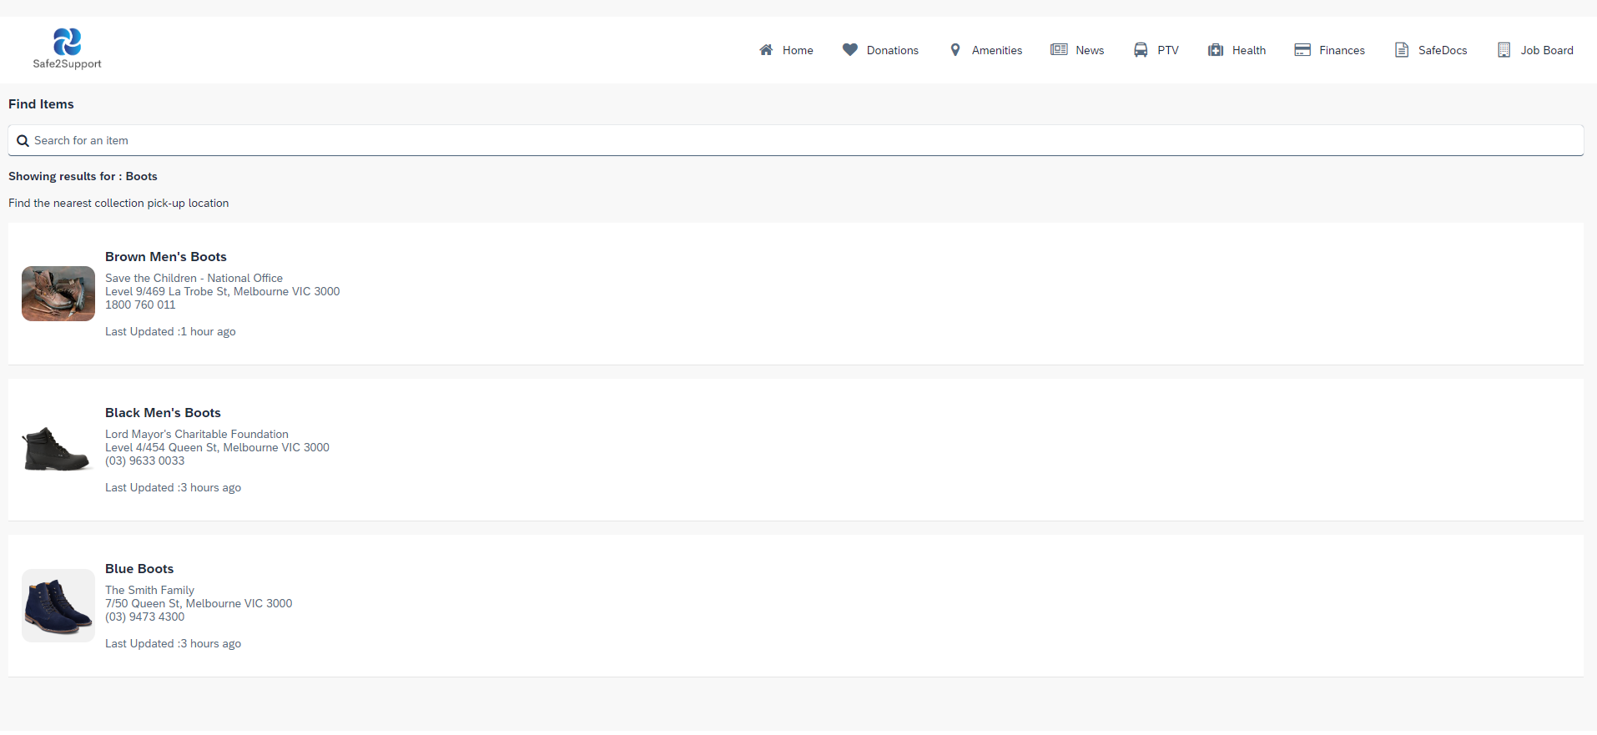

Purpose
The 'Boots Results Screen' allows users to view a variety of boots available at nearby donation centers, enhancing their ability to quickly find suitable footwear. This part of the "Find Items" service helps users efficiently locate and choose boots that meet their needs.

UI Design Description
- Top Navigation Bar: This bar facilitates seamless navigation to other essential parts of the application, such as the 'Home Page,' 'Events,' and other sections, enhancing user flow and accessibility.
- Results Header: Clearly displays that the current search results are for boots, keeping users informed and focused on the task at hand.
- Item Listings: Each boot listing provides an image, along with vital details such as the donation center’s name, its address, contact number, and last update timestamp. This ensures users have all the necessary information to make an informed decision.
- Interactive Elements: Users can click on any listing to get more details or start navigation to the respective collection point directly from this screen.

Evaluation Metrics/Quality Assurance Steps
- Search Relevance: Regular testing to ensure the search function correctly identifies and lists boots based on user queries.
- Information Accuracy: Maintain current and accurate details about the boots and their availability to facilitate user decisions.
- Usability Testing: Continuous assessment of the navigation bar and other interactive elements to guarantee a user-friendly experience across the application.
The 'Boots Results Screen' is a crucial component of the app that supports individuals in quickly finding specific types of footwear. By offering detailed and updated listings along with easy navigation options, it ensures a streamlined process for users to access necessary items, contributing significantly to the app’s aim of aiding those in need.

Amenities
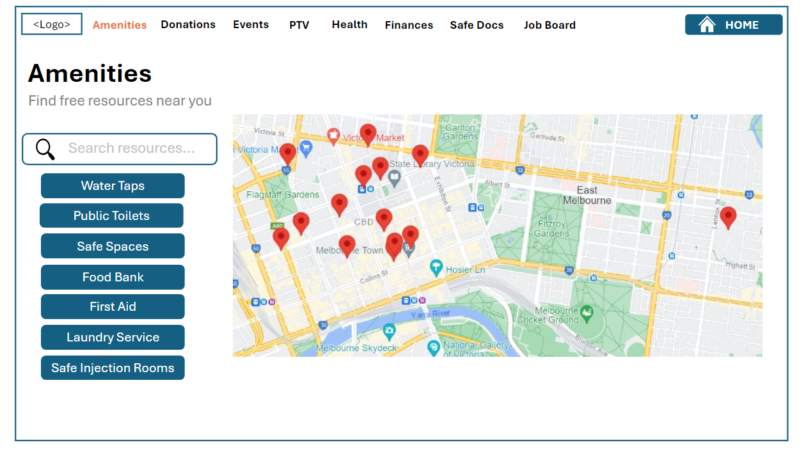

Purpose
The Amenities screen is designed to assist users in finding free resources and services available near them. This is particularly beneficial for individuals seeking essential services such as water, food, safe spaces, or medical aid. The interactive nature of the screen, intended to include a map, aims to provide a user-friendly and visually intuitive way to locate these resources.

UI Design Description
- Top Navigation Bar: The top navigation bar remains consistent with other screens in the application, providing easy access to different sections like Home, Donations, News, Health, Finances, and more.
- Search Functionality:
The search bar allows the user to search for any public amenities on the map, which comes with certain pre-set markers for widely used amenities like public toilets, laundromats and water taps.
- Interactive Map:
The map linked to an external HTML page which has been web embedded onto the UI screen. It is designed to be the central element of this screen, allowing users to visually locate amenities on an interactive map. The map displays icons or markers representing different types of amenities, color-coded based on the category.

- Amenities Categories:
A list of widely used amenities list is available for users to quickly filter the type of amenities they are looking for:
    - Water Taps
    - Public Toilets
    - Safe Spaces
    - Food Bank
    - First Aid
    - Laundry Services
    - Safe Injection Rooms
Each button, when clicked, would highlight corresponding locations on the interactive map, making it easy for users to see where these services are available.

Code and Integration Components
- API Integration: The map is linked to an external HTML webpage which has been integrated with Google Maps API to allow for dynamically updated data that reflects the current amenities available. This was done using the get record collection call as a REST API in SAP Build. The HTML, CSS and JS scripts used to run the map have been attached below. The markers on the map are based on the location latitude and longitude.

HTML Script:
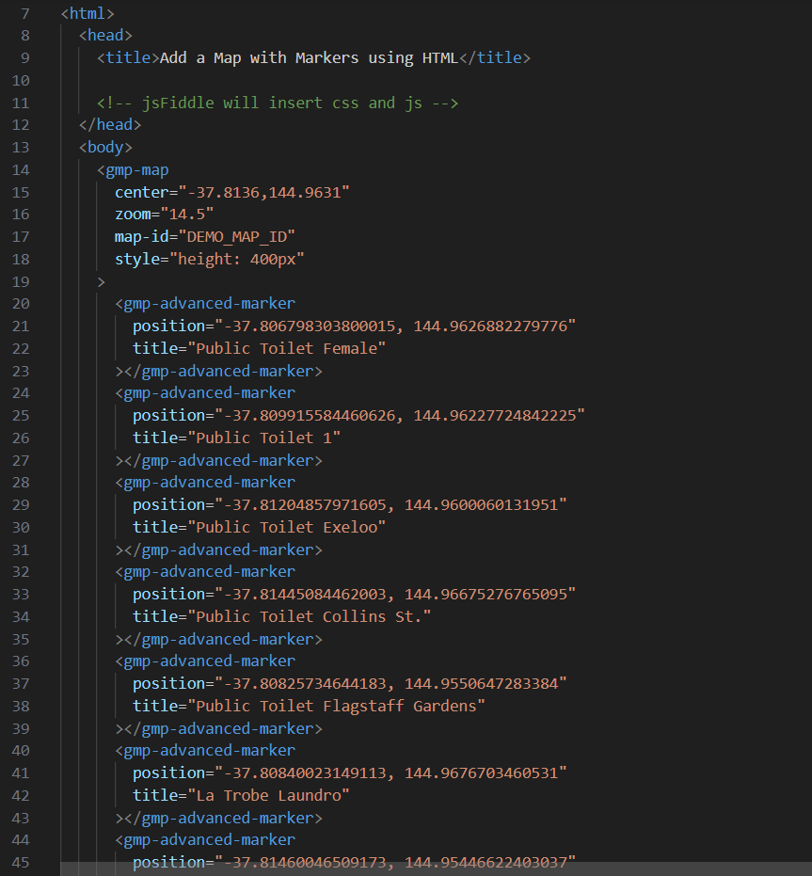
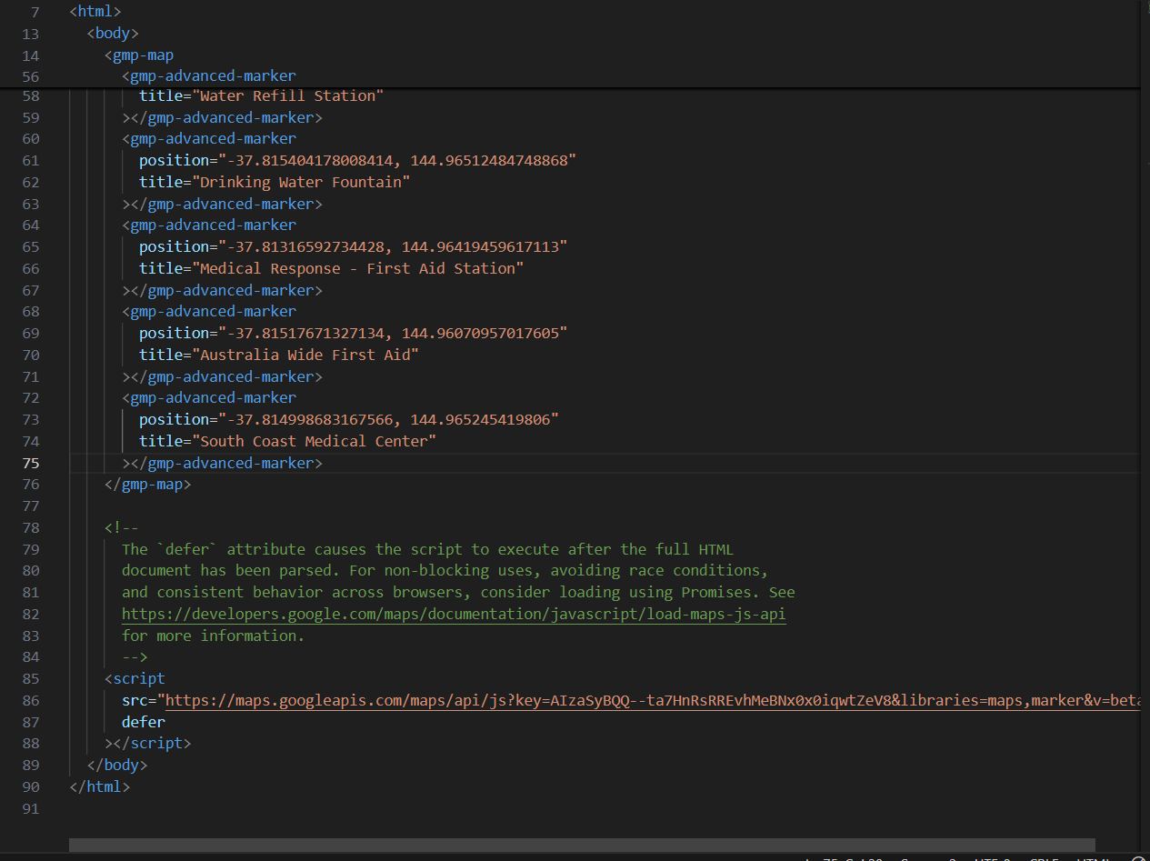

CSS Script:
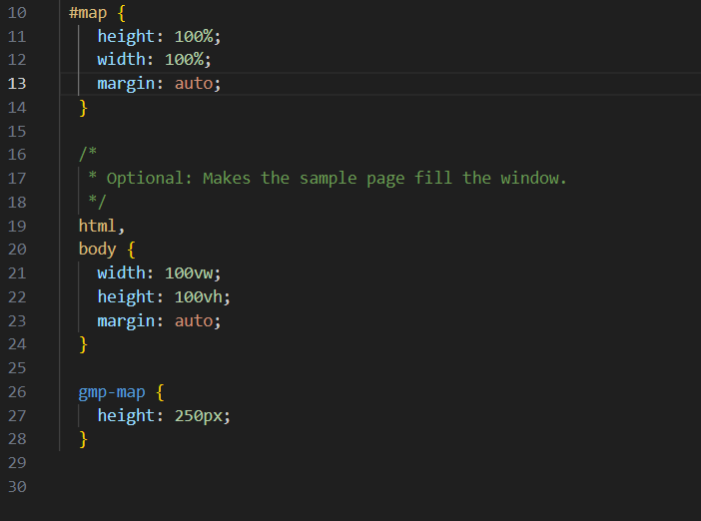
Java Script:
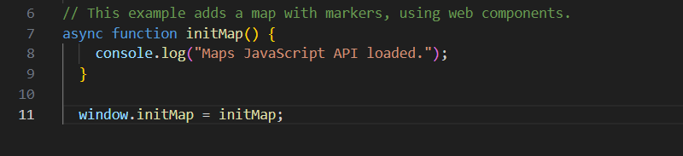
- Filter and Search: The search bar and category buttons would work in conjunction with the map API to filter and display relevant results.

Evaluation Metrics/Quality Assurance Steps
- Functionality Testing: Ensure that the map loads correctly on supported platforms and accurately displays the location of amenities.
- User Experience Testing: Conduct tests to ensure that users can easily find and use the search and filter features to locate nearby services.
The Amenities screen is a powerful tool for users to locate essential services near them through an interactive map. The design is focused on ease of use, with clear categorization and search capabilities that ensure users can quickly find the resources they need. Even though the map feature is currently unsupported on the platform, the screen layout and conceptual design highlight the intent to provide a comprehensive, user-friendly experience.

News
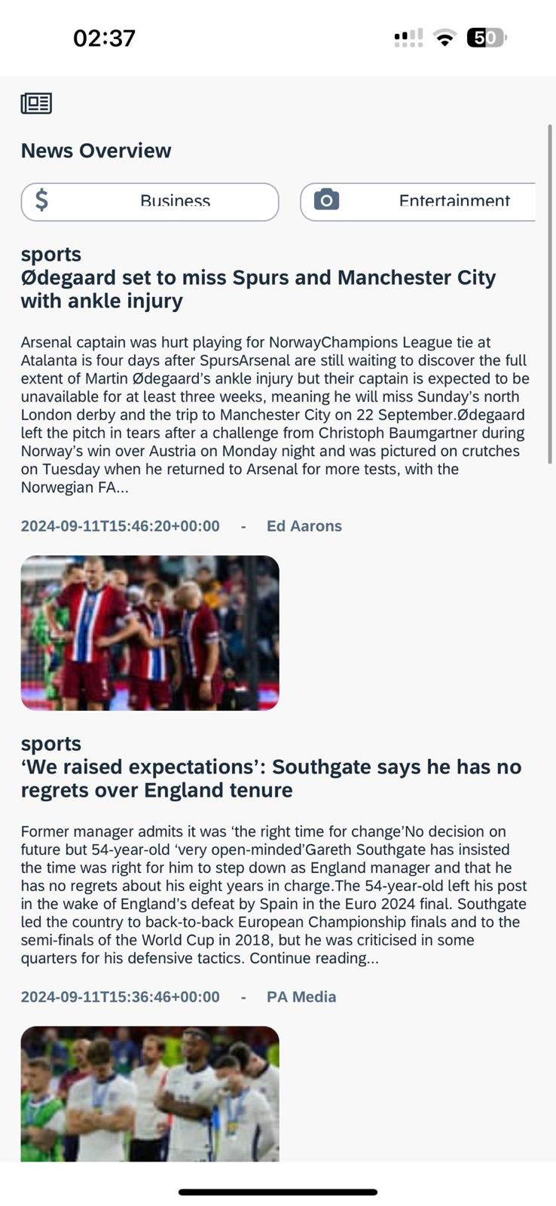

Purpose
The News screen is designed to keep users informed by providing access to the latest headlines across various categories. This screen serves as an information hub, allowing users to quickly browse news topics that are relevant to them. The categories are clearly organised to ensure that users can easily navigate to the type of news they are most interested in.

UI Design Description
- Top Navigation Bar: As seen in previous screens, the top navigation bar is consistent across the application. It includes options for Home, Donations, Amenities, News, PTV, Health, Finances, SafeDocs, and Job Board, allowing users to move seamlessly between these different sections.
- Category Selection: Users can click on any of the category buttons to filter the news by that specific topic. Upon selection, the headlines list updates to show the most recent and relevant articles in that category.
- News Overview Section:
  - Category Buttons: The screen features several buttons that represent different news categories:
    - Business
    - Entertainment
    - Health
    - Science
    - Sports
    - Technology
    - General
  - Each button is visually distinct, with icons representing the category, making it easy for users to recognize and select their preferred news type.
  - Headlines List: Below the category buttons is a list of headlines. Currently, these headlines are placeholders with the label "Headline -", indicating where news items will be populated. Each headline will link to more detailed news articles or summaries within the category selected by the user.

Code
- Mediastack free API will be used to facilaite the news articles
- API endpoint is created in xano, as mediastak does not have have HTTP and SAP Build Apps API requests need HTTP
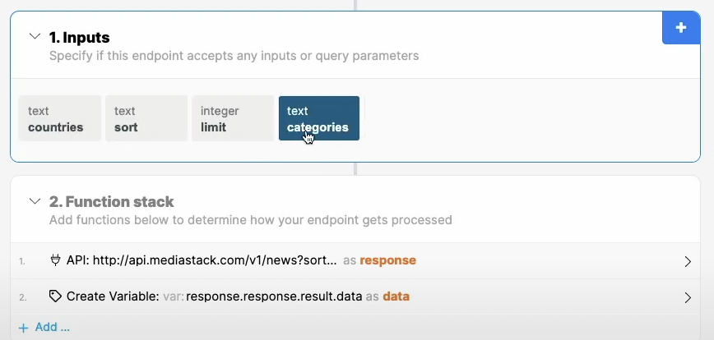
- App variables are set up in SAP Build Apps
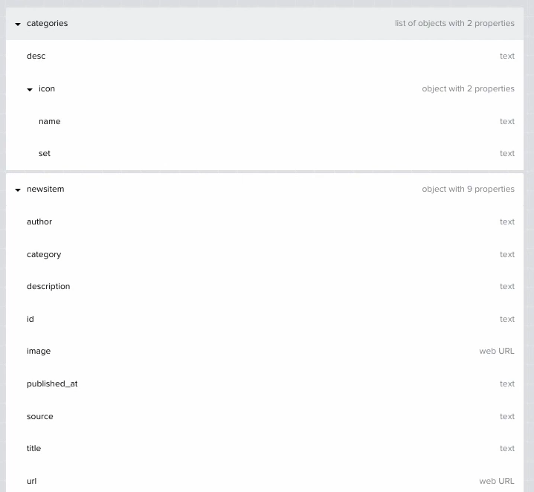
- Logic is set up for the data variable, it needs to be GET RECORD COLLECTION instead of GET RECORD as we are pulling in multiple items (News articles will have a title, published, date, author, category description etc.). The same is done for category.
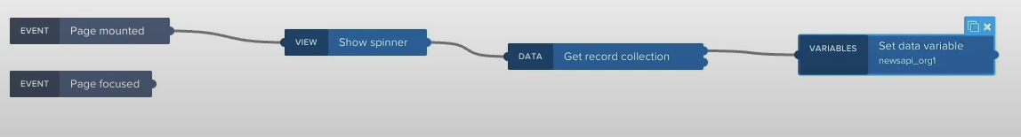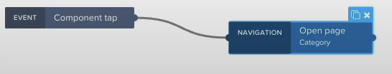
- A list is created to display the news items and this is set to repeat with the news API data variable. The same is done for the binding of the categories.
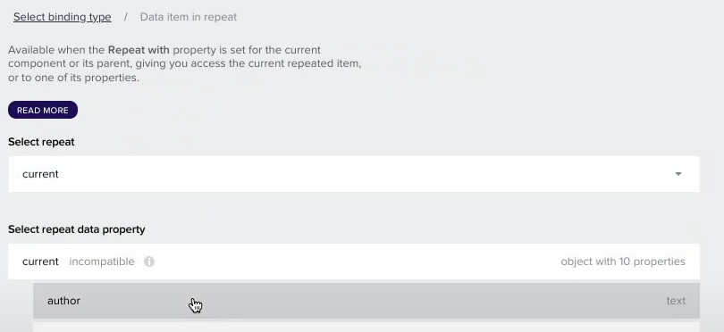

Evaluation Metrics/Quality Assurance Steps
- Content Relevance Testing: Verify that the API correctly populates the news categories with up-to-date and relevant articles. This includes testing the accuracy and timeliness of the headlines.
- Usability Testing: Conduct usability tests to ensure that users can easily navigate between different news categories and access detailed news content without confusion or difficulty.
- Performance Testing: Ensure that the News screen loads quickly and efficiently, even when accessing large amounts of data from the news APIs.
The News screen is a critical component of the application, providing users with quick and easy access to the latest news across a variety of topics. The clear organization of categories, combined with dynamic content updates, ensures that users are always informed about the subjects that matter most to them. By integrating with reliable news APIs, this screen becomes a valuable resource for staying updated on current events.

PTV

Purpose
The PTV (Public Transport Victoria) page aims to provide users with real-time information on public transport disruptions and services. By integrating with the PTV API, the page will help users stay informed about bus and train disruptions and plan their journeys effectively, which is crucial for those who rely on public transport for their daily needs.

UI Design Description
- Top Navigation Bar: A consistent feature across all screens, allowing users to navigate to other parts of the application, including 'Donation,' 'Finances,' and more.
- Bus Disruptions Section: Displays real-time updates on any disruptions affecting bus services. This section will show information such as service delays, route changes, and expected resolution times.
- Train Disruptions Section: Provides users with information about disruptions affecting train services. Similar to the bus disruptions section, it will include details about delays, cancellations, and alterations to train services.
- Plan Journey Service: An interactive feature allowing users to plan their journeys using the 'Plan Journey' service. Users can input their starting point and destination to receive details on the best routes, travel times, and any potential disruptions along the way.

Code
- API Integration: The PTV API will be integrated using HTTP requests to fetch real-time data on bus and train disruptions.
- Disruptions Display: Use of dynamic content loading to update the bus and train disruptions sections with the latest information from the API.
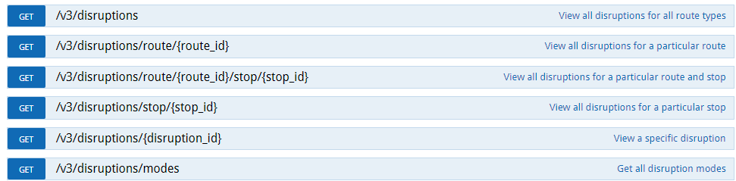
- Journey Planner: The 'Plan Journey' service will utilize PTV iframes webview component to provide route planning capabilities. This involves sending user inputs to the PTV and processing the response to display suggested routes and travel information.
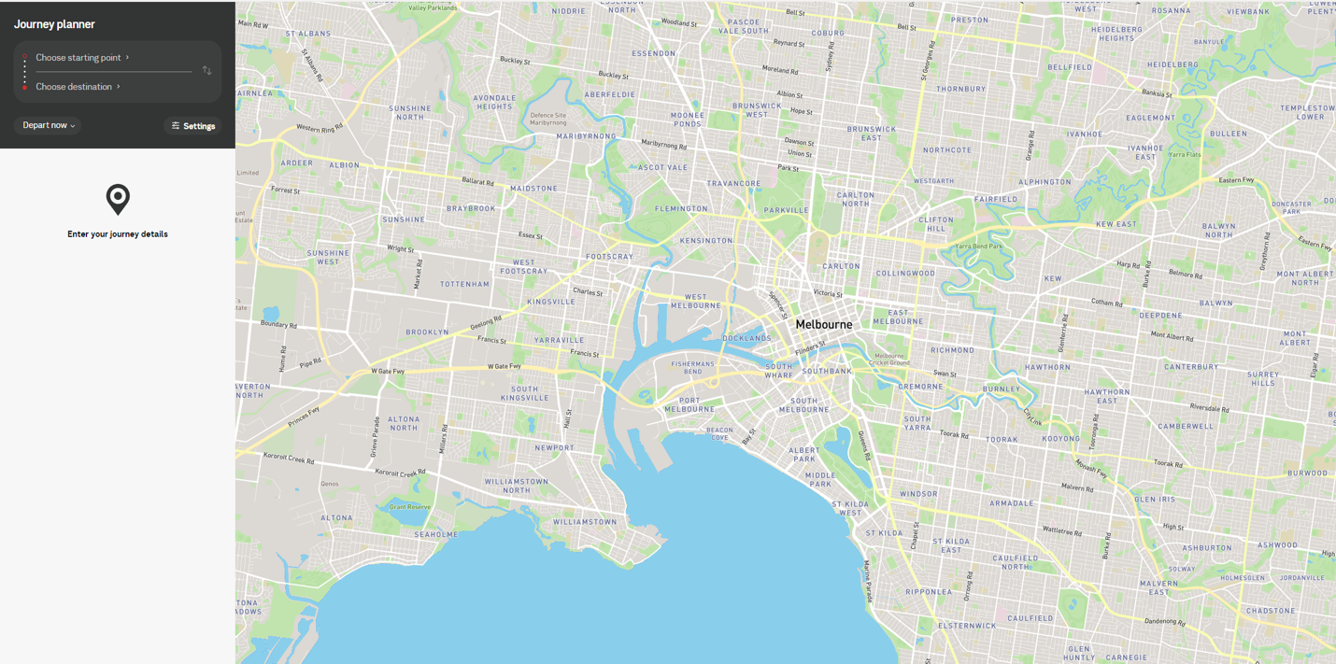

Evaluation Metrics/Quality Assurance Steps
- Accuracy of Disruptions Information: Regularly verify that the information about bus and train disruptions is accurate and up-to-date by cross-checking with official PTV sources.
- Journey Planner Functionality: Test the 'Plan Journey' feature to ensure it correctly processes user inputs and provides accurate routing information, including travel times and potential disruptions.
- API Response Time: Measure the time taken for the PTV API to respond to requests and ensure that it does not significantly impact the user experience.
- Usability Testing: Ensure that the sections for bus and train disruptions, as well as the 'Plan Journey' service, are easy to use and navigate, providing a smooth experience for users seeking transport information.
The PTV page is a vital component of the application, providing users with real-time updates on public transport disruptions and a journey planning tool. Its integration with the PTV API ensures that users have access to accurate and timely information, helping them make informed decisions about their travel and navigate public transport efficiently.

Health
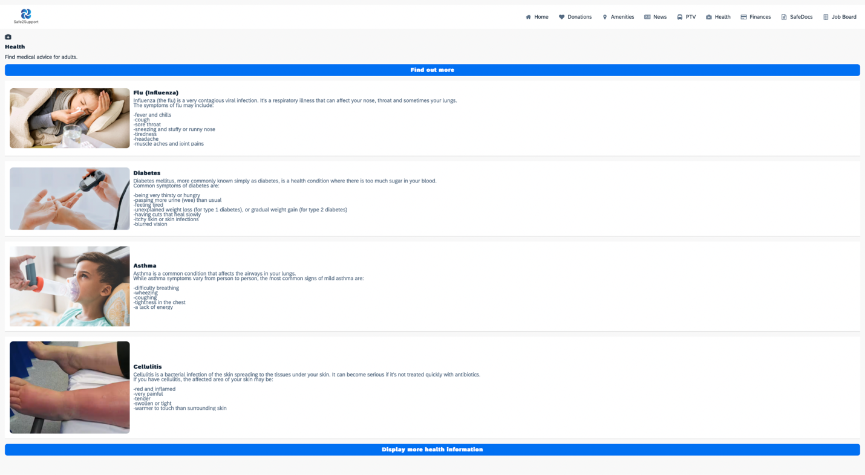

Purpose
The Health page is designed to provide users with essential information on common viruses and diseases, focusing on helping homeless individuals quickly identify symptoms and understand basic health conditions. This feature aims to improve access to health knowledge, which is critical for early detection and prevention of serious illnesses.

UI Design Description
- Top Navigation Bar: A consistent element that allows users to navigate to other pages within the application, such as 'PTV,' 'Donations,' and 'Find Clothes.'
- Health Conditions List: The page will display a list of common viruses and diseases, each represented by a card or tile with the name of the condition. The screen will provide comprehensive information on the condition, including overview and common symptoms.

Code
The Health screen, as seen in the provided screenshot, consists of large item lists displaying health information such as symptoms of common diseases. The code to implement this in SAP Build Apps involves the following key components: a static data source, UI elements for card/tile layout, and image handling. Below is a technical breakdown:
- Data Source (Static)
Since the health information (disease names, symptoms, and images) does not require dynamic updates from external APIs or databases, the data will be managed as a static data source. This involves creating a collection of data objects directly within the app.
Steps:
- Define a static collection for health information.
- Each health condition (e.g., Flu, Diabetes, Asthma) will have fields like condition_name, description, symptoms, image_url.

UI Design Implementation
The list of health conditions is visually displayed in card/tile form. For this, we can leverage the "List Component" in SAP Build Apps, where each card is dynamically populated from the static data collection.
1. Steps:
- Use the List Component to loop through the static collection and display each health condition as an item.
- Each list item will have:
  - An image (condition image)
  - Title (name of the condition)
  - Text (description and symptoms)

- Image Handling
The images for each health condition are included in the static data source as URLs. These images are stored in the app's assets directory.
Steps:
- Upload images (e.g., flu, diabetes, asthma) to the SAP Build media manager.
- Reference these images in the static data source by using their paths

- Navigation
For seamless user experience, the Top Navigation Bar (referenced earlier) is consistent across all pages. Navigation logic for moving between the Health, Home, PTV, Donations, and other services will use standard navigation features in SAP Build Apps.
Steps:
- Bind the Top Navigation Bar buttons to the respective screens (e.g., Health, Donations).
- Configure On Click Events for each navigation button to transition to the appropriate page.

Evaluation Metrics/Quality Assurance Steps
- Content Accuracy: Regularly review and update the health information to ensure it remains accurate, reliable, and relevant.
- Performance Testing: Ensure that the page loads quickly and efficiently.
The Health page is a critical feature of the application, providing users with accessible and easy-to-understand information on common health conditions. By offering guidance on symptoms, the page empowers users, particularly those without regular access to healthcare, to take proactive steps in managing their health and seeking medical assistance when necessary.

Finances
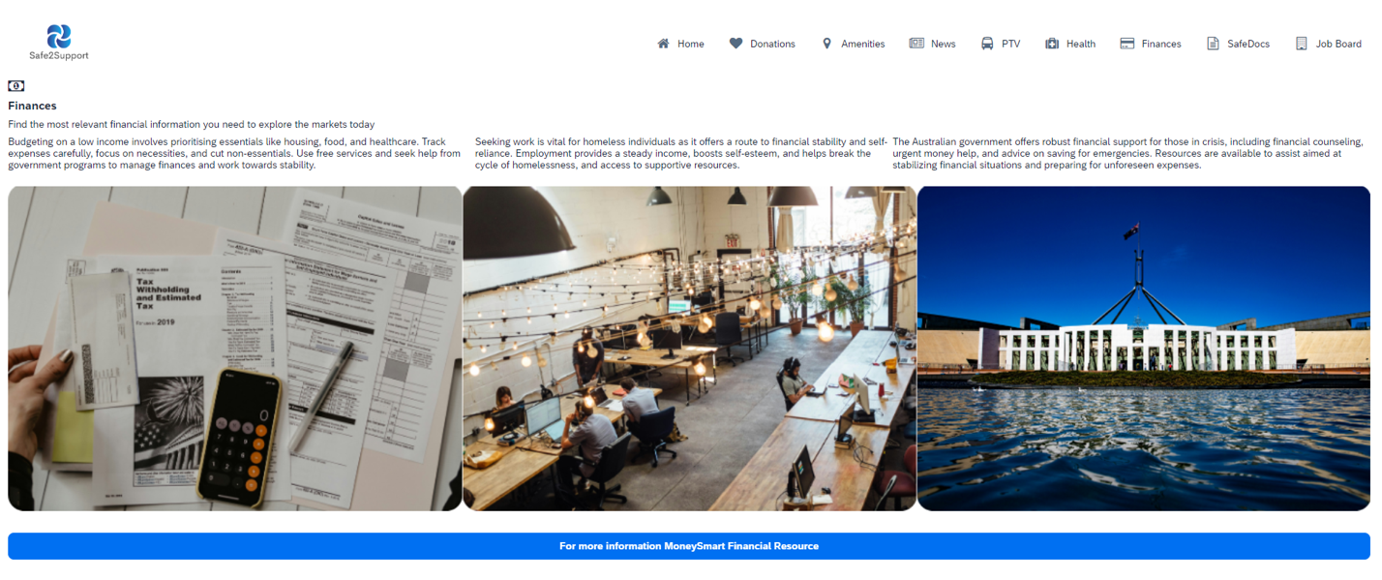

Purpose
The Finances page is designed to offer crucial financial advice and resources tailored to the needs of homeless individuals or those at risk of homelessness. The page aims to provide practical guidance on managing finances, seeking employment, and accessing government support, empowering users to work towards financial stability and independence.

UI Design Description
- Top Navigation Bar: A consistent element that allows users to easily navigate to other sections of the application, such as 'Health,' 'PTV,' and 'Donations.'
- Financial Advice Sections:
  - Budgeting on a Low Income: This section provides advice on managing limited finances, emphasizing the importance of prioritizing essential needs such as housing, food, and healthcare. It encourages users to track their expenses and cut out non-essential spending, offering practical tips on making the most of a tight budget.
  - Seeking Employment: This section highlights the importance of finding work as a means to achieve financial stability. It discusses the benefits of employment, such as a steady income and improved self-esteem, and provides information on resources and support available to help individuals secure jobs.
  - Government Financial Support: This section outlines the financial assistance programs offered by the Australian government, including financial counseling, emergency money help, and advice on saving for future emergencies. It directs users to resources that can help them stabilize their financial situations and prepare for unexpected expenses.
- Interactive Elements:
  - Call-to-Action Button: At the bottom of the page, a prominent button directs users to the MoneySmart website, a government-run platform offering comprehensive financial services and advice. This button is labeled "Learn More on MoneySmart" and will open the website in a new tab or window.

Code
The Finances screen, as observed in the provided screenshot, offers static information and resources on financial stability, including advice on budgeting, employment, and government financial support. The code implementation in SAP Build Apps will focus on creating static content with an interactive button linking to external resources.
- Static Content (Financial Advice)
Similar to the Health screen, this screen contains static content with multiple financial advice sections such as Budgeting on a Low Income, Seeking Employment, and Government Financial Support. Each section contains an image and related text.

Steps:
- Use a Static Data Collection to define the content for each section, including images and text descriptions.
- Call-to-Action Button (Link to MoneySmart)
At the bottom of the screen, there is a Call-to-Action (CTA) Button that directs users to an external website (MoneySmart). This requires setting up a button component and assigning it an action to open a new tab with the MoneySmart website.
Steps:
- Use a Button Component labeled "For more information MoneySmart Financial Resource".
- In the button’s On Click event, configure a URL redirect action that opens the external MoneySmart resource in a new tab.

- UI Structure and Component Binding
Each section in the Finances screen contains an image with text describing the financial advice. To implement this in SAP Build Apps, the structure of the screen will rely on a flexbox/grid layout to ensure proper image alignment and text wrapping.
Steps:
- Use a Flex Layout Component to display each section in a card-like format, similar to a grid, ensuring that each image aligns with the text and the sections are responsive across devices.
- Bind the static data (section titles, descriptions, and images) to their respective components.

- Navigation Bar Implementation
To maintain consistency across all screens, the Top Navigation Bar remains the same as in other parts of the app. This bar allows users to navigate between sections like Health, PTV, and Donations.
Steps:
- Bind each navigation item in the Top Navigation Bar to its respective screen.
- Configure the On Click Events for each navigation button to transition the user to the appropriate section of the app.

- Image Handling
The images associated with each financial advice section will be uploaded to the Media Manager in SAP Build Apps, and their URLs will be referenced in the static data collection.
Steps:
- Upload all relevant images (budgeting, employment, government support) to the app’s Media Manager.
- Use the image paths in the image_url field of the static data collection to ensure correct binding.

Evaluation Metrics/Quality Assurance Steps
- Content Accuracy and Relevance: Regularly review and update the financial advice to ensure it reflects current best practices and available government programs. Collaborate with financial experts to validate the content.
- Usability Testing: Conduct testing with target users to ensure that the page is easy to navigate and that the financial advice is clear and actionable.
- Performance Testing: Ensure that the page loads quickly and performs smoothly, even on devices with lower processing power or slower internet connections.
The Finances page is a vital component of the application, offering practical and accessible financial advice to individuals facing homelessness or financial hardship. By providing clear guidance on budgeting, employment, and accessing government support, the page equips users with the knowledge they need to work towards financial stability. The integration with the MoneySmart website further enhances the value of the page, connecting users with a wealth of additional resources to support their financial well-being.

SafeDocs
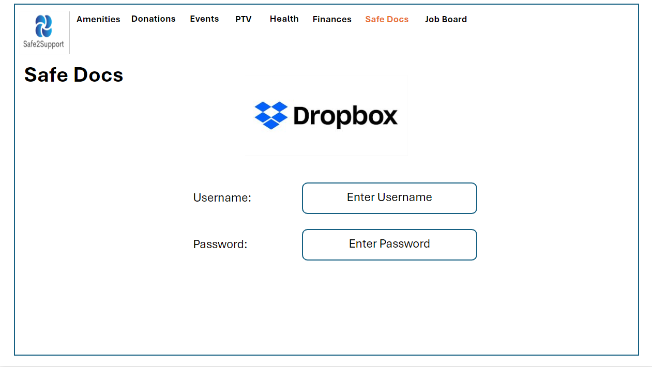
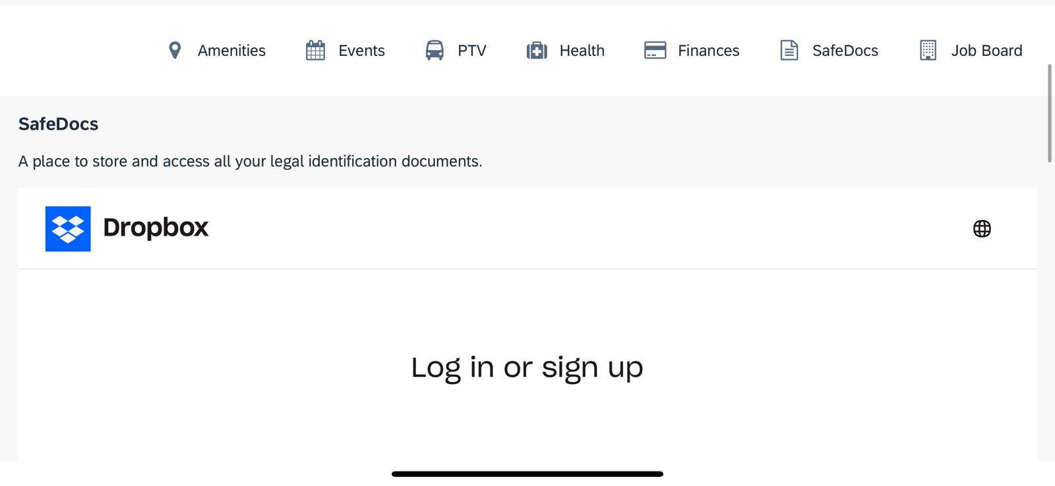

Purpose
The SafeDocs page provides a secure and convenient solution for storing and accessing important legal identification documents. This feature is especially critical for individuals facing homelessness or financial instability, as it ensures they can safely access essential documents whenever needed. By integrating with Dropbox, SafeDocs offers users a familiar and trusted platform for document management, adding a layer of security and reliability.

UI Design Description
- Top Navigation Bar: A consistent element across the application, allowing users to easily navigate to other sections such as 'Finances,' 'Health,' and 'PTV.'
- Dropbox Integration: The page includes a Dropbox login button prominently displayed at the top of the screen. This button allows users to securely log into their Dropbox account and access their stored documents. The Dropbox branding and design are used to ensure users recognize and trust the integration. Once logged in, users are presented with a list of their stored legal identification documents, such as ID cards, birth certificates, passports, and other vital records. The documents are displayed in a simple, easy-to-navigate list format, with options to preview, download, or share each document.

Code
Dropbox will be loaded in as a webview component where end users can access their accounts securely as dropbox provides end to end encryption. Dropbox gives the ability to share files with user input email hence this will allow end users of Safe2Support to share their important files with relevant parties or for printing purposes.

Evaluation Metrics/Quality Assurance Steps
- Security Testing: Conduct thorough testing to ensure that the Dropbox integration is secure, protecting user data during login, file upload, and access. This includes testing against common security vulnerabilities such as unauthorized access and data breaches.
- Usability Testing: Engage users in testing the document management features, including the ease of logging in, uploading documents, and navigating the document list. Feedback from users will be used to refine the user experience.
- Performance Testing: Ensure the SafeDocs page loads quickly and efficiently, particularly when handling large document lists or high-resolution document previews. The integration with Dropbox should function smoothly across different internet connection speeds.
- Reliability Testing: Verify that the Dropbox API integration consistently works as expected, even during high-traffic periods or when the user’s Dropbox account contains a large number of files.
The SafeDocs page is a crucial feature within the application, providing users with a safe, reliable, and accessible way to store and manage their legal identification documents. By integrating with Dropbox, SafeDocs leverages a trusted platform known for its security and user-friendly interface. The seamless experience of logging in, uploading, and accessing documents ensures that users always have their vital records at their fingertips, which is especially important for those in vulnerable situations. The design and functionality of the SafeDocs page are aimed at making document management as simple and secure as possible, giving users peace of mind.

Job Board
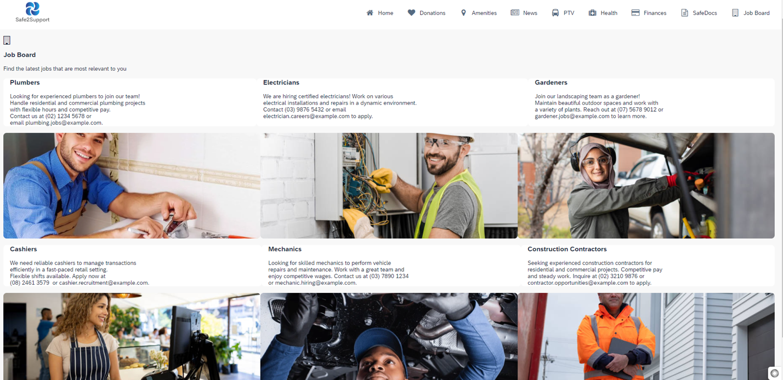

Purpose
The Job Board page is designed to help users find employment opportunities that are most relevant to their skills and needs. This feature is essential for individuals seeking to improve their financial stability and independence. The page presents job listings in a clear and engaging manner, making it easy for users to browse and identify job opportunities that match their qualifications and interests.

UI Design Description
- Top Navigation Bar: A consistent navigation bar at the top of the screen allows users to move seamlessly between different sections of the application, such as 'SafeDocs,' 'Finances,' and 'Health.'
- Job Listings Section:
  - Job Titles and Images: The main section of the Job Board page features six job listings. Each listing includes:
    - Job Title: A bold and clear title that describes the job being offered, such as "Plumber Required," "Electrician Needed," or "Mechanic Position."
    - Job Image: Directly below each title, there is a relevant image representing the job. For example, the "Plumber Required" listing might include an image of a plumber at work.

Code
The Job Board screen displays static job listings, each paired with relevant images and a brief description. Each job listing provides contact information for applications. This implementation will use SAP Build Apps to display job data in a list format with associated images and interactive elements for contacting job providers.
- Static Job Listings
The Job Board screen, as seen in the screenshot, showcases static job listings like Plumbers, Electricians, Cashiers, etc. Each job listing includes an image, a job title, a job description, and contact information.
Steps:
- Create a Static Data Collection to store job listing information, including titles, descriptions, contact details, and image URLs.

- UI Structure and Layout
The job listings are displayed in a card format with large images followed by job descriptions and contact information. This can be achieved using a Grid Layout to display two listings per row (on larger screens) and one per row on mobile devices.
Steps:
- Use a Flexbox Layout or Grid Layout to arrange job listings into two columns for larger screens
- Bind the data for job titles, descriptions, and images as part of the job listings.

- Responsive Design
Ensure the Job Board screen is fully responsive across devices by adjusting the layout for different screen sizes.
Steps:
- Use media queries to adjust the number of job cards per row depending on the device width.

Navigation Bar Implementation
Like the other pages, the Top Navigation Bar will allow users to navigate between sections such as Health, PTV, and Finances.
Steps:
- Bind each item in the Top Navigation Bar to transition to its respective page.
- Ensure the navigation bar remains consistent with other pages of the app.

- Image Management
The images associated with each job listing (e.g., plumbers, electricians, cashiers) will be uploaded to SAP Build Apps' Media Manager.
Steps:
- Upload all relevant images for each job listing to Media Manager.
- Bind the image paths in the image_url field of the static data collection to ensure the images appear correctly.

Evaluation Metrics/Quality Assurance Steps
- User Engagement Testing: Track user interactions with the Job Board page to see which job listings receive the most clicks and engagement. Use this data to optimize the relevance and placement of job listings.
- Usability Testing: Conduct tests to ensure that users can easily navigate the job listings and find the information they need. Feedback will be gathered on the clarity of job titles, the relevance of images, and the overall layout.
- Performance Testing: Verify that the Job Board page loads quickly, even when displaying high-resolution images or when there are many users accessing the page simultaneously. The API calls to fetch job data should be optimized for speed and efficiency.
- Content Update Testing: Ensure that the job listings are regularly updated without any delays or errors. The system should seamlessly integrate new job postings and remove outdated ones to maintain the page's relevance.
The Job Board page is a vital resource within the application, providing users with easy access to the latest job opportunities tailored to their needs. By presenting job listings with clear titles and relevant images, the page is designed to be both informative and engaging. The dynamic integration of job data ensures that users are always seeing the most current opportunities, while the intuitive UI design makes the job search process straightforward and accessible. The Job Board page supports the overall mission of helping users achieve financial independence and stability through meaningful employment.

Challenges & Recommendations

Integration of Map APIs Across Devices
Integrating map APIs into the service kiosks presents challenges in ensuring consistent functionality across various devices and platforms. Disparities in responsiveness and accuracy of map features can be particularly pronounced in less accessible urban areas, where detailed mapping is crucial.
Recommendation: It is advisable to implement a robust testing protocol that covers multiple devices and operating conditions to ensure seamless integration. Partnering with map service providers for enhanced support and incorporating multiple data sources may also improve reliability and comprehensive coverage.

Delays and Inaccuracies in PTV API Updates
One significant challenge is the potential delays and inaccuracies in updates from Public Transport Victoria (PTV) APIs, which can lead to outdated information being displayed. This misinformation can be critical for users relying on timely public transport information for essential activities, such as job interviews.
Recommendation: Establishing a more direct communication channel with PTV could facilitate more timely data updates. Additionally, setting up a system for users to report inaccuracies and a secondary verification mechanism using real-time updates could mitigate the impact of this challenge.

Security and Data Privacy Concerns
Handling sensitive information, especially in services like SafeDocs and financial advice tools, necessitates stringent security measures to protect against data breaches.
Recommendation: Implementing advanced encryption methods, secure data storage solutions, and regular updates to security protocols will help safeguard user data. Additionally, providing transparent information about data usage and security measures will help build trust among users.

Scalability and Maintenance of Kiosk Systems
As user demands grow, the kiosk systems must be capable of scaling up seamlessly to accommodate additional features or services. Maintaining the physical and software components of the kiosks is also crucial to ensure their longevity and functionality.
Recommendation: Designing scalable architecture from the start and establishing a regular maintenance schedule are recommended strategies. This proactive approach will help prevent future issues and ensure the kiosks can evolve with user needs.

Engagement and Awareness Among the Homeless Population
Generating awareness and engagement among the homeless population about the kiosk's benefits may pose a challenge, especially if there is initial unfamiliarity or distrust of the technology.
Recommendation: Collaborative outreach programs with local homeless shelters, community centers, and social services can be effective in educating potential users about the kiosks. Additionally, incorporating mechanisms for user feedback will allow continuous improvement of the services based on real user experiences.
By addressing these challenges with thoughtful solutions and proactive measures, the project aims to deliver a valuable resource for the homeless community, significantly enhancing their access to essential services and information.

Conclusion
The Safe2Support project represents a transformative approach to addressing the challenges faced by homeless individuals by leveraging urban infrastructure in innovative ways. Throughout this project, our team has developed a multifunctional application that integrates into public payphones, providing homeless individuals with easy access to essential services and information that significantly enhance their quality of life.
The comprehensive nature of the services offered—from health information, public transport updates, and financial guidance to secure document storage and job opportunities—ensures that the application addresses a wide spectrum of needs, empowering users towards greater independence and stability. Each service component has been meticulously designed with the end user's experience in mind, ensuring that the interface is intuitive, user-friendly, and accessible to all, regardless of their familiarity with digital technologies.
The project's success hinges not only on the functionality of these services but also on the rigorous evaluation metrics and quality assurance processes that have been established to maintain high standards of accuracy, reliability, and user satisfaction. Through continuous testing and feedback mechanisms, we have refined our offerings to meet the practical needs of homeless individuals effectively.
Despite facing challenges such as integrating diverse APIs and ensuring consistent service across various devices, our strategic approach and adaptive methodologies have enabled us to overcome these hurdles, illustrating the project’s robustness and scalability. Recommendations for future iterations include deeper integration with local government databases, enhancement of the physical infrastructure of payphones, and expanded outreach to ensure that the benefits of this project reach all corners of the homeless community.
As we conclude, the Safe2Support project stands as a testament to the power of technology and innovation in social welfare. By repurposing existing urban elements, we have not only provided a lifeline to those in need but also set a precedent for similar initiatives globally. This project has the potential to serve as a blueprint for future endeavors aiming to merge technology with social care, ultimately leading to a more inclusive and supportive society.
In moving forward, we remain committed to refining and expanding our services, ensuring that every individual facing homelessness can access the tools they need to improve their circumstances. The journey of Safe2Support is just beginning, and its evolution will continue to inspire and make a measurable impact on lives across urban landscapes.

